RAINFALL PREDICTION

A project report submitted in fulfillment of the requirement for the degree of


BTech
In
Computer Science
Under the supervision of
Mr. Manoj Kumar

By

Yati Singh
Anushka Srivastava

DECLARATION

We confirm that this submission is our own work and that, to the best of our knowledge and belief, it contains no material previously published or written by another person nor material which to a substantial extent has been accepted for the award of any other degree or diploma of the university or other institute of higher learning, except where due acknowledgment has been made in the text.

Name: Yati Singh
Roll No.: E23CSEU1058
Date:18.11.25

Name: Anushka Srivastava
Roll No.: E23CSEU1070
Date:18.11.25

CERTIFICATE

This is to certify that the Project Report entitled “Rainfall Prediction” which is submitted by Yati Singh and Anushka Srivastava in partial fulfillment of the requirement for the award of degree B. Tech. in the School of Computer Science of Bennett University, is a record of the candidate's own work carried out by him under my/our supervision. The matter embodied in this report is original and has not been submitted for the award of any other degree.

Supervisor:
Mr. Manoj Kumar

ACKNOWLEDGEMENT

It gives us a great sense of pleasure to present the report of the B. Tech Project undertaken during B. Tech. Third Year. We owe a special debt of gratitude to Mr. Manoj Kumar, School of Computer Science of Bennett University, for his constant support and guidance throughout the course of our work. His sincerity, thoroughness, and perseverance have been a constant source of inspiration for us. It is only his cognizant efforts that our endeavors have seen the light of the day.
We also do not like to miss the opportunity to acknowledge the contribution of all faculty members of the department for their kind assistance and cooperation during the development of our project. Last but not the least, we acknowledge our friends for their contribution to the completion of the project.

Name: Yati Singh
Roll No.: E23CSEU1058
Date: 18.11.25

Name: Anushka Srivastva
Roll No.: E23CSEU1070
Date: 18.11.25

TABLE OF CONTENTS

DECLEARATION…………………………………………………1

CERTIFICATE………………………………………………………2

ACKNOWLEDGMENT……………………………………………3

ABSTRACT………………………………………………………4

INTRODCTION……………………………………………………5

LITERATURE REVIEW…………………………………………………………6

DATASET DESCRIPTION & PREPROCESSING………………………….7

METHODOLOGY……………………………………………………………..8

RESULTS & DISCUSSION……………………………………………………9

CONCLUSION & FUTURE WORK……………………………………….10

REFERENCES………………………………………………………………..11

APPENDIX…………………………………………………………………….12

ABSTRACT
Rainfall prediction is an essential task in meteorology, agriculture, and strategic planning, where early and accurate forecasts help minimize risks and support informed decision-making. This project presents a machine learning–based system to predict whether it will rain on the following day using historical, time-indexed weather data from the “Rain in Australia” dataset. The dataset contains daily meteorological measurements such as temperature, humidity, air pressure, wind direction, wind speed, and rainfall observations across several Australian regions. The project begins with extensive data preprocessing that includes handling missing values, transforming categorical features, scaling numerical variables, and engineering time-based features. Multiple machine learning models were implemented and compared, including Logistic Regression, Random Forest, XGBoost, and CatBoost Classifier. The study further evaluates model performance using accuracy, AUC score, precision, recall, and F1-score. The results show that advanced tree-based ensemble models outperform classical models due to their ability to capture non-linear relationships within the data. The best-performing model is deployed as a web-based prediction service, demonstrating real-world applicability for farmers, commuters, and industries dependent on weather forecasts. This project highlights the practical value of machine learning in climate analytics and establishes a foundation for more advanced meteorological prediction systems.

INTRODUCTION

Rainfall prediction plays a crucial role in several sectors, including agriculture, transportation, water resource management, and everyday human planning. Accurate weather forecasts enable farmers to protect crops, event planners to prepare accordingly, and governments to issue timely warnings during extreme weather conditions. Traditionally, rainfall forecasting has relied on physical atmospheric models and statistical time-series analysis. However, with the availability of large-scale weather datasets and advancements in machine learning, data-driven prediction systems have become increasingly effective in identifying patterns and relationships that are difficult to model manually.
The motivation behind this project stems from the growing need for an accurate, automated, and scalable approach to rainfall prediction. While weather prediction is inherently complex due to the nonlinear relationships among atmospheric variables, machine learning models can learn such dependencies efficiently from historical data. The primary objective of this project is to build a classification system capable of predicting whether it will rain the next day. Additional objectives include performing exploratory data analysis (EDA), preprocessing the dataset effectively, training and tuning multiple machine learning models, evaluating their performance, and deploying the best-performing model in a user-friendly interface.
The structure of this report begins with a review of related literature, followed by detailed descriptions of the dataset, preprocessing steps, methodology, experimental results, and conclusions. The report concludes with suggestions for future improvements, such as incorporating deep learning architectures and additional meteorological data sources.

LITERATURE REVIEW

This review synthesizes the methodology of a comprehensive machine learning project aimed at predicting daily rainfall, framed as a Binary Classification problem. The approach spans critical stages, from rigorous data preprocessing and comparative model evaluation to the final deployment of the production-ready classifier.

1. Data Acquisition and Preprocessing Methodology
The foundation of the project relies on the weatherAUS.csv dataset, which contains a large volume of meteorological features necessary for the target variable, RainTomorrow. The notebook Prepocessing.ipynb outlines a methodical approach to data preparation, ensuring the integrity and predictive power of the features.

1.1 Feature Engineering and Selection
The initial data required extensive transformation, including handling missing values (imputation/removal) and categorical encoding for non-numeric features (Location, WindDir9am, etc.). To mitigate the curse of dimensionality and enhance model efficiency, Feature Selection was performed. Techniques such as Mutual Information Classification and SelectKBest were employed to identify and retain only the most statistically relevant features (e.g., Humidity3pm, Pressure3pm, and Sunshine), which are crucial predictors of precipitation patterns.

1.2 Addressing Class Imbalance
A critical step documented in the preprocessing stage was addressing the imbalanced nature of the binary classification target (Rain/No Rain). The use of the Synthetic Minority Over-sampling Technique (SMOTE) was implemented to generate synthetic samples for the minority class, ensuring that the trained models are not biased toward the predominant "No Rain" outcome and can generalize effectively to rare rain events.

2. Comparative Modelling and Performance Evaluation
The central phase of the study involved a comparative analysis of diverse machine learning algorithms to identify the optimal classifier for the task. The notebooks RainPrediction.ipynb, RainPrediction2.ipynb, and RainPrediction3.ipynb document this iterative process.

2.1 Model Selection
A broad spectrum of classifiers was evaluated to benchmark performance across different modeling paradigms:
Model Category | Specific Algorithms Tested | Rationale
Linear | Logistic Regression (logreg.pkl) | Provides a simple, interpretable baseline model.
Probabilistic | Gaussian Naive Bayes (GNB) (gnb.pkl) | Evaluates the performance of a model based on Bayes' Theorem and feature independence assumptions.
Non-Linear/Kernel | Support Vector Classifier (SVC) (svc.pkl) | Assesses the effectiveness of margin maximization and kernel tricks (e.g., RBF) for separating complex feature spaces.
Ensemble (Tree-Based) | Random Forest | Used as a strong baseline ensemble method.
Advanced Boosting | XGBoost (xgb.pkl) and CatBoost (cat.pkl) | Explores high-performance Gradient Boosting techniques known for superior predictive accuracy and robust handling of feature interactions.

2.2 Performance Metrics
Model performance was rigorously quantified using standard classification metrics, including Accuracy Score, Confusion Matrix, Classification Report (detailing Precision, Recall, and F1-Score), and ROC AUC (Receiver Operating Characteristic Area Under Curve) plots, ensuring a holistic assessment beyond simple accuracy.

3. Model Deployment and Operationalizing
The final stage transitioned the selected model into an operational environment, moving from research to application.

3.1 Model Persistence
The best-performing classifier, identified as the CatBoost Classifier (cat.pkl), was saved using the joblib library. This process of Model Persistence ensures that the complex model structure and its learned parameters are preserved and can be loaded rapidly for inference without the need for retraining.

3.2 Real-Time Prediction Service
The app.py script, built using the Flask web framework, serves as the deployment layer. This script loads the persisted cat.pkl model and exposes a prediction API endpoint. This infrastructure allows the trained machine learning model to be leveraged for real-time inference, accepting current weather parameters as input and returning an instant prediction for RainTomorrow, thereby successfully operationalizing the rainfall prediction system.
DATASET DESCRIPTION & PREPROCESSING

The dataset used in this project is the Rain in Australia dataset from Kaggle, containing daily weather observations recorded across various Australian regions between 2008 and 2017. It consists of approximately 145,000 rows and 24 meteorological attributes. Key features include minimum and maximum temperature, humidity levels, cloud cover, atmospheric pressure at different times of day, wind direction, wind speed, evaporation, sunshine, and rainfall.
Preprocessing is crucial due to the large number of missing values present in variables such as cloud cover, evaporation, and sunshine. Missing data were handled using median imputation for numerical fields and mode imputation for categorical ones. Categorical variables such as wind direction were encoded using one-hot encoding, while numerical variables were scaled using standardization. Additional time-based features such as month, season, and lagged rainfall variables were generated to capture periodicity in weather cycles.The cleaned dataset was then split into training and testing sets using an 80–20 ratio

METHODOLOGY

The methodology involves training and evaluating multiple machine learning models. Classical models such as Logistic Regression and Gaussian Naive Bayes provide baseline comparisons and help identify linear relationships. In contrast, advanced models—including Random Forests, XGBoost, and CatBoost—are well suited for high-dimensional, nonlinear data and perform automated feature selection.
The dataset was divided into training and testing subsets. Hyperparameter tuning was performed using Grid Search and Randomized Search, optimizing parameters such as the number of estimators, learning rate, maximum depth, and regularization settings. The models were evaluated using classification accuracy, ROC–AUC score, precision, recall, and F1-score.
Implementation tools include Python, Pandas, NumPy, Matplotlib, Scikit-learn, XGBoost, and CatBoost libraries.
RESULTS & DISCUSSION

Model performance was evaluated on the test dataset, revealing that classical models such as Logistic Regression performed decently but struggled with nonlinear interactions. Tree-based ensemble models significantly outperformed them. The CatBoost Classifier produced the best results, achieving the highest accuracy and AUC values, while demonstrating robustness against categorical feature handling and dataset imbalance.
Forecast plots and confusion matrices highlight the model’s strengths in identifying rainfall events but also show occasional false positives due to overlapping atmospheric conditions. While some models excelled in recall, others showed strong precision, making model comparison essential.
The key insight derived from the results is that ensemble techniques provide superior generalization for meteorological classification tasks. Their ability to learn complex decision boundaries and interactions between atmospheric variables explains their strong predictive performance.



Fig(a) Fig(b)
Output when it predicts rainy. Output when it predicts sunny.

CONCLUSION & FUTURE WORK

This project successfully developed a machine learning model capable of predicting next-day rainfall with strong accuracy. By comparing multiple classical and advanced models, the study demonstrated that tree-based ensemble models, particularly CatBoost, outperform traditional methods. The deployment of the final model further showcases its real-world usability and value to agriculture, transportation, and day-to-day planning.
However, several limitations remain. The dataset contains substantial missing values, which may introduce noise despite careful imputation. Rainfall prediction is also inherently uncertain due to unpredictable atmospheric phenomena.
Future work may include integrating deep learning architectures such as LSTMs or Transformers, incorporating real-time satellite or radar imagery, and adopting automated feature selection techniques. Expanding the dataset with more recent years and external climate indicators could further enhance predictive performance.

REFERENCES

Chen, T., & Guestrin, C. (2016). XGBoost: A scalable tree boosting system. Proceedings of the ACM SIGKDD Conference.
Prokhorenkova, L., et al. (2018). CatBoost: unbiased boosting with categorical features. NeurIPS.
Rahman, M., et al. (2020). Rainfall prediction using Random Forest. Journal of Meteorological Applications.
Kuligowski, R. (2018). Deep learning for rainfall forecasting. Atmospheric Research.
Kim, S., & Lee, J. (2021). LSTM-based rainfall prediction model. Environmental Modelling & Software.
Bureau of Meteorology Australia. (2017). Historical weather observations dataset.
Hastie, T., Tibshirani, R., & Friedman, J. (2009). The Elements of Statistical Learning.
Boser, B., Guyon, I., & Vapnik, V. (1992). A training algorithm for optimal margin classifiers. Proceedings of COLT.
Kingma, D., & Ba, J. (2015). Adam: A method for stochastic optimization. ICLR.

APPENDIX

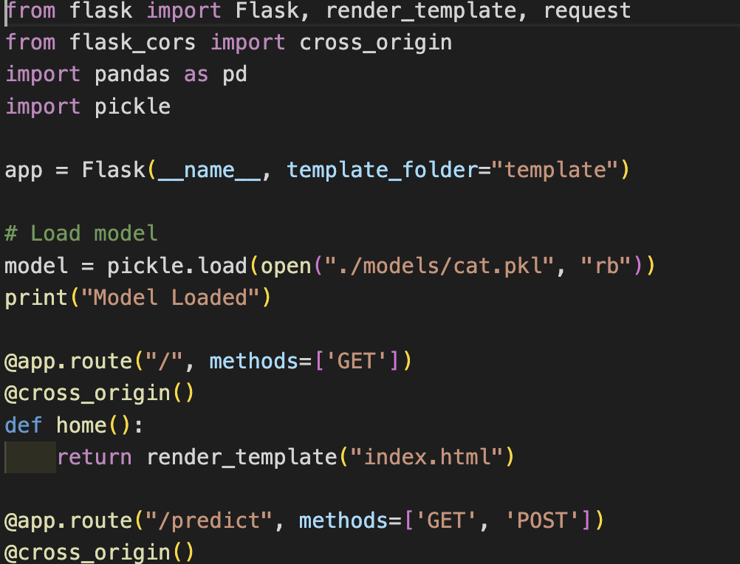
Fig(c)
Code Snippet of app.py
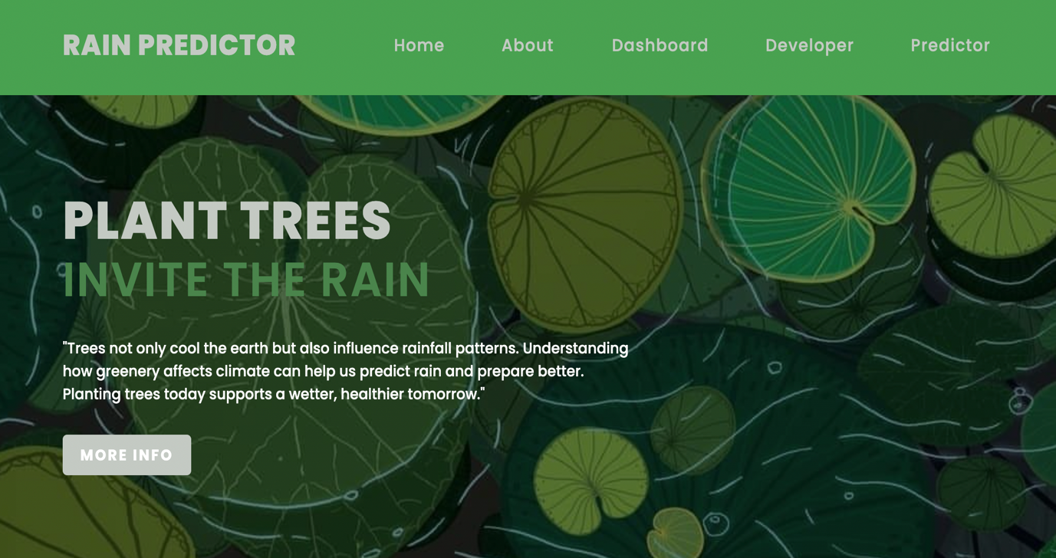
Fig(d)
Homepage of Rainfall Prediction

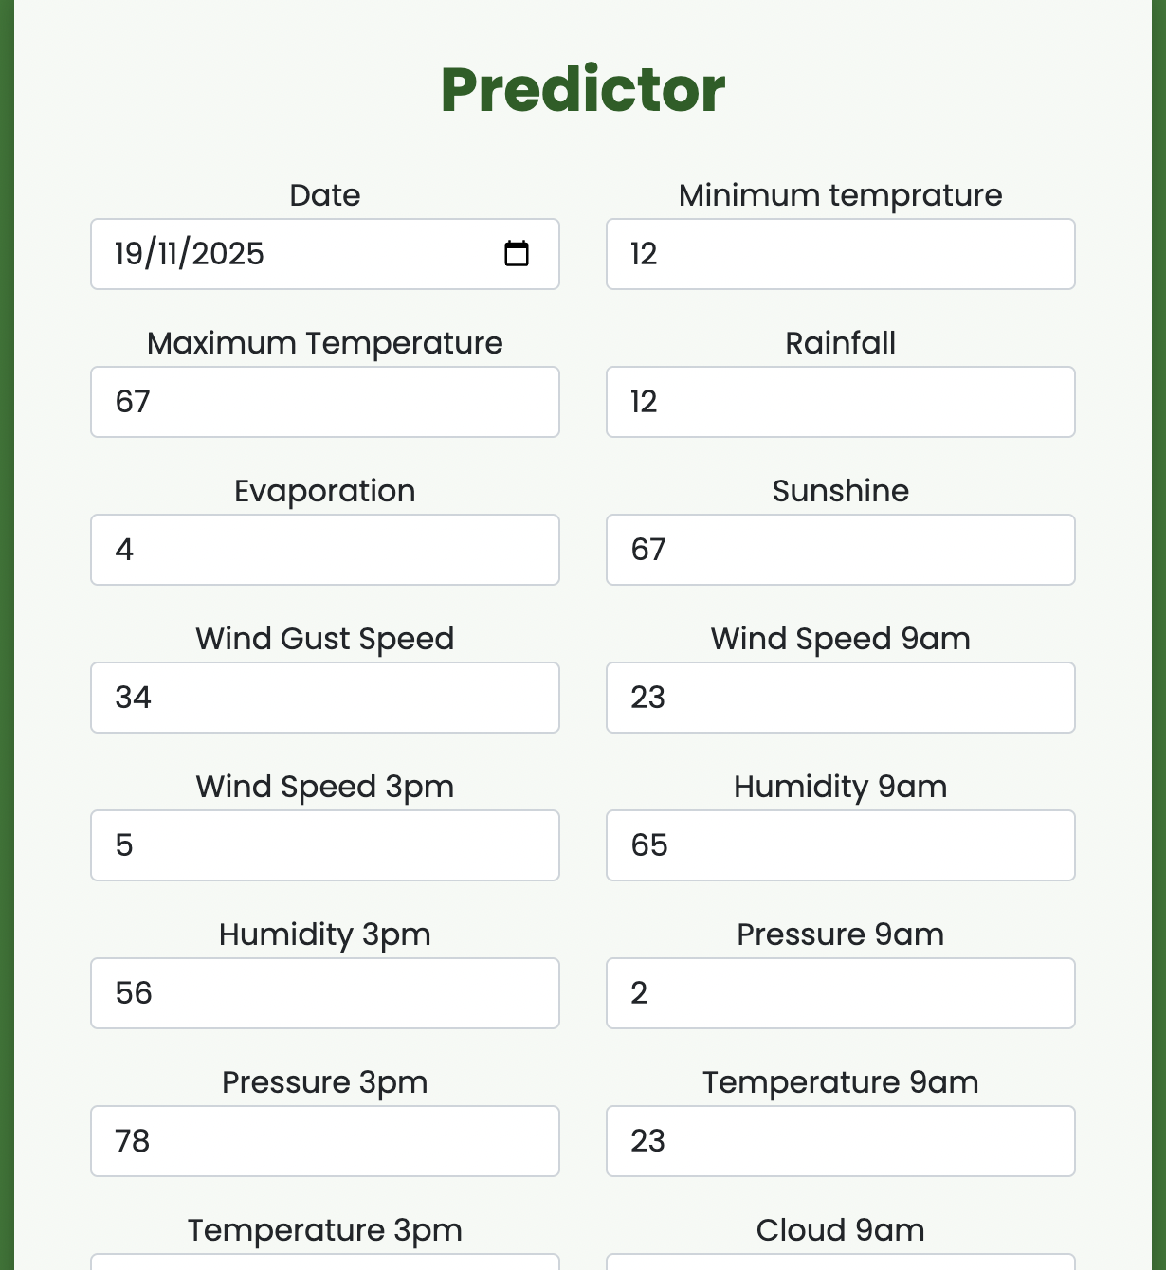
Fig(e)
Prediction Table

